Visit the applicaiton

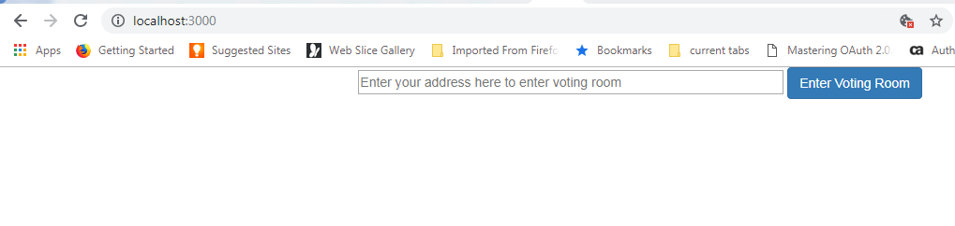

Enter Address to enter into the voting room

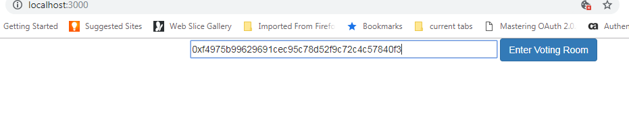

Shows the list of candidates

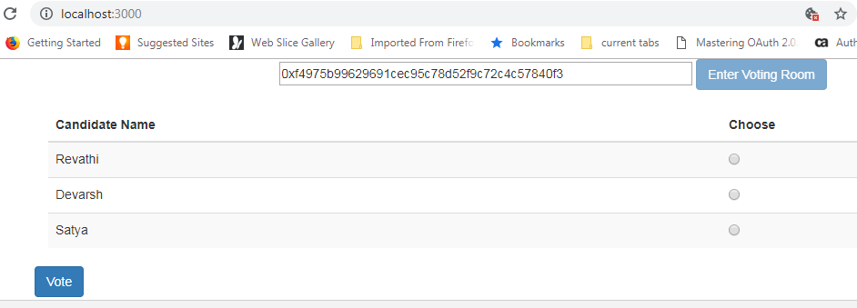

Select a candidate and click on vote

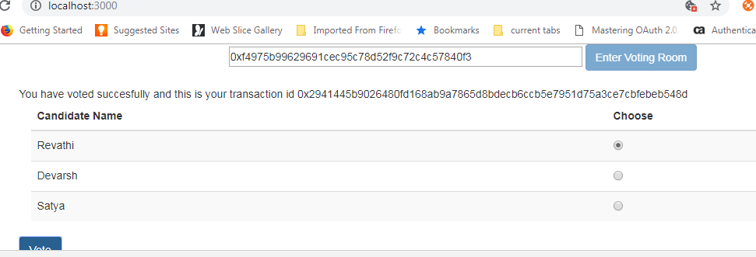

Contract owner will be shown with additional option to end voting process

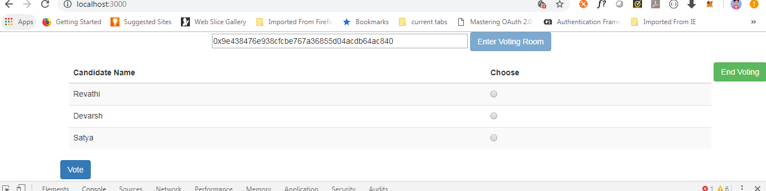

Vote multiple times for different candidates

End the voting as owner

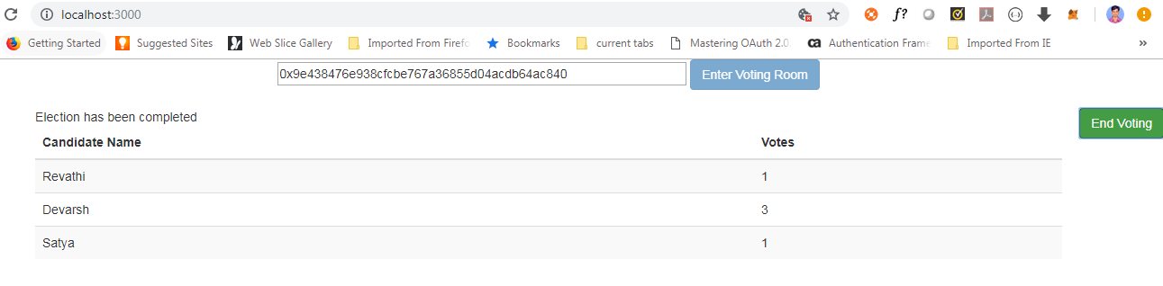

Once the voting is ended, all the users logging into the application will be shown with results page

